Lesson 24

**Load Testing Basics with Apache JMeter**

Level 1

**1. Create a set of GET, POST, PUT, PATCH, and DELETE requests to the JSONPlaceholder that are sent within 10 seconds in 3 iterations**

**2. Apply three different assertions to each of the requests.**

**3. The results of the tests should be received via the following Listeners:**

* **View Results in Tree**
* **Summary Report.**

**4. Describe the conclusions of the test results (based on the reporters) in a separate file.**

**5. Add the created test plan and a document describing the results of the reporters' execution to your GitHub repository.**

Steps:

1. Create ‘Beet Seed’
2. Thread Group Setup
   1. Add a Thread Group - Practice
   2. Configuration:
      1. Number of Threads: 15 Users
      2. Ramp-up period: 10 sec
      3. Loop count: 3 iterations
3. Add Sampler
   1. HTTP Request
   2. Configure the Sampler with the appropriate method (GET, POST, PUT, PATCH, DELETE)
4. Add Listeners:
   1. View Results in Tree
   2. Summary Reports
5. Add Assertions
   1. Response Assertion
   2. Duration Assertion
   3. Size Assertion
6. Run Homework

**GET Response**

Assertion configuration:

* Response Assertion: - Response Code - Patterns to Test: 200
* Duration Assertion: - Duration in milliseconds: 150
* Size Assertion: - Size in Bytes >=28600

View Results Tree

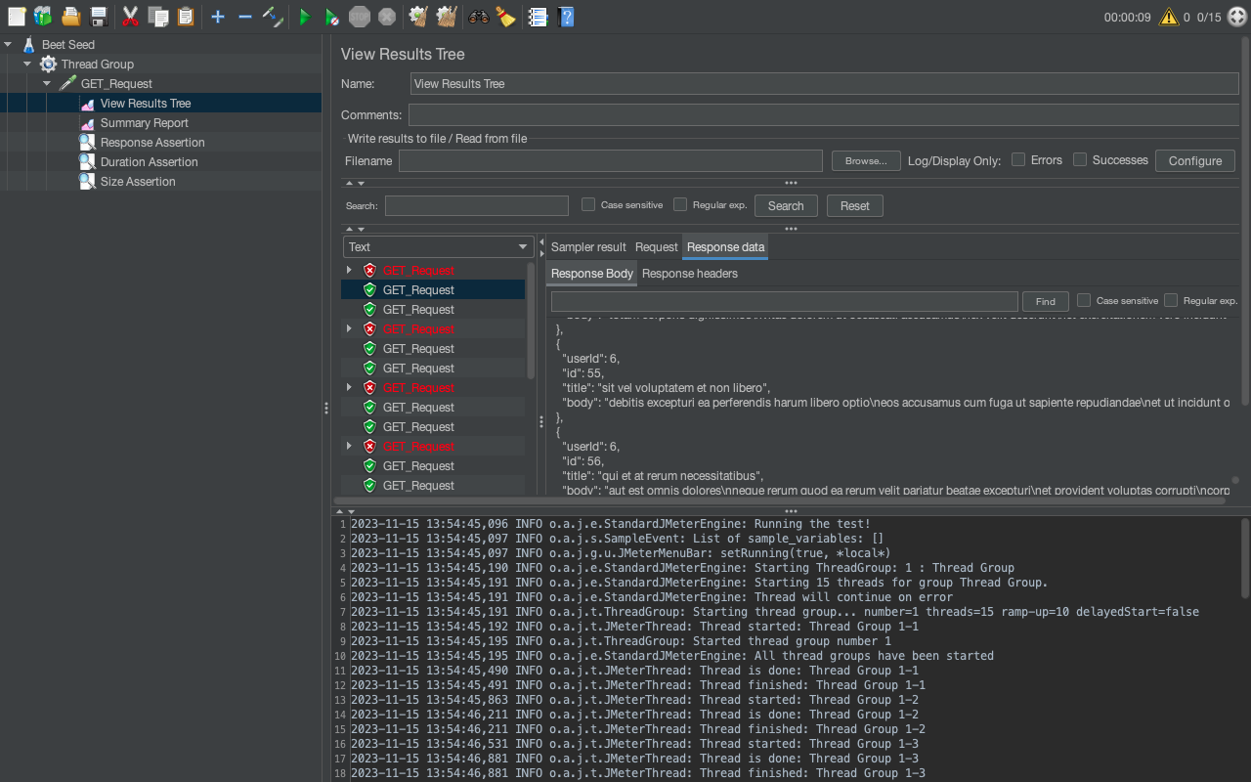

Summary Report

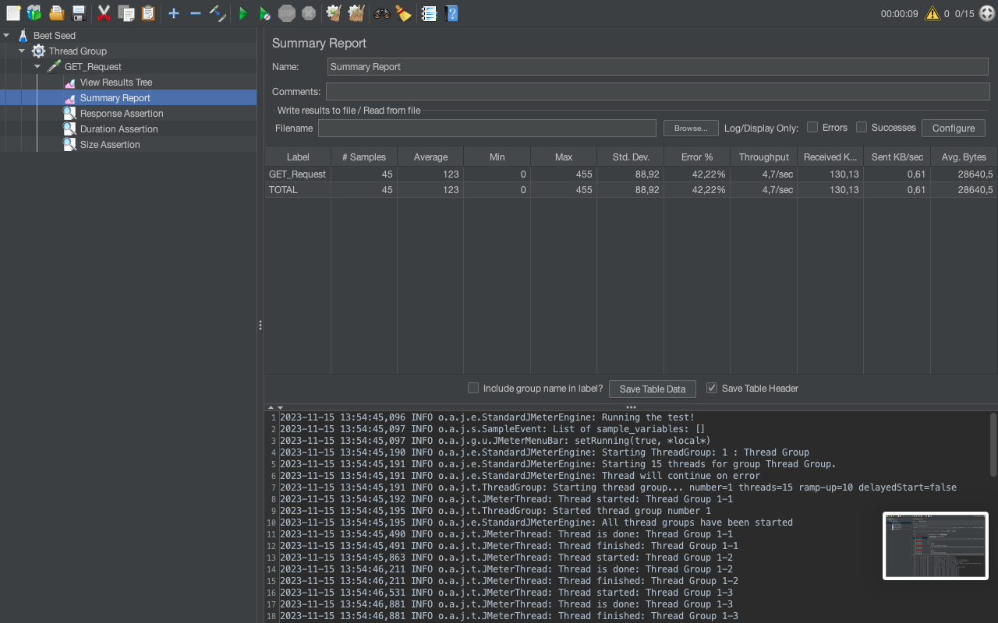

**POST Request**

Assertion Configuration:

* Response Assertion: - Response Code - Patterns to Test: 201
* Duration Assertion: - Duration in milliseconds: 150
* Size Assertion: - Size in Bytes >=1200

View Results Tree

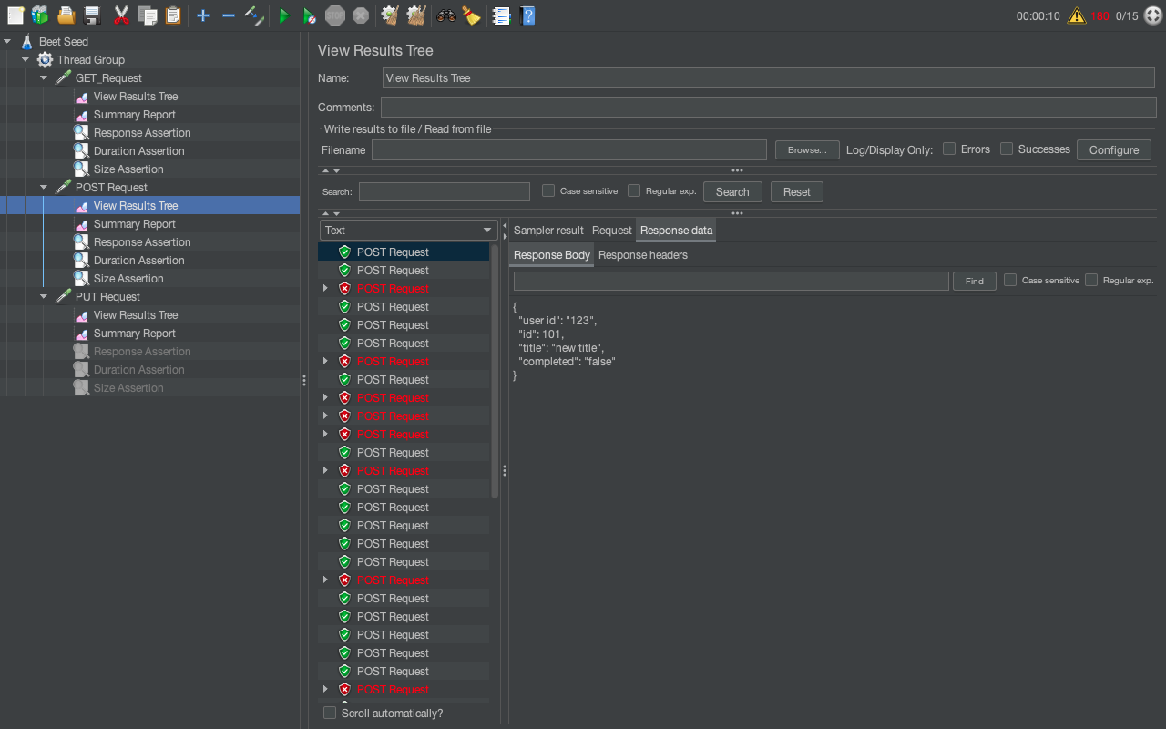

Summary Report

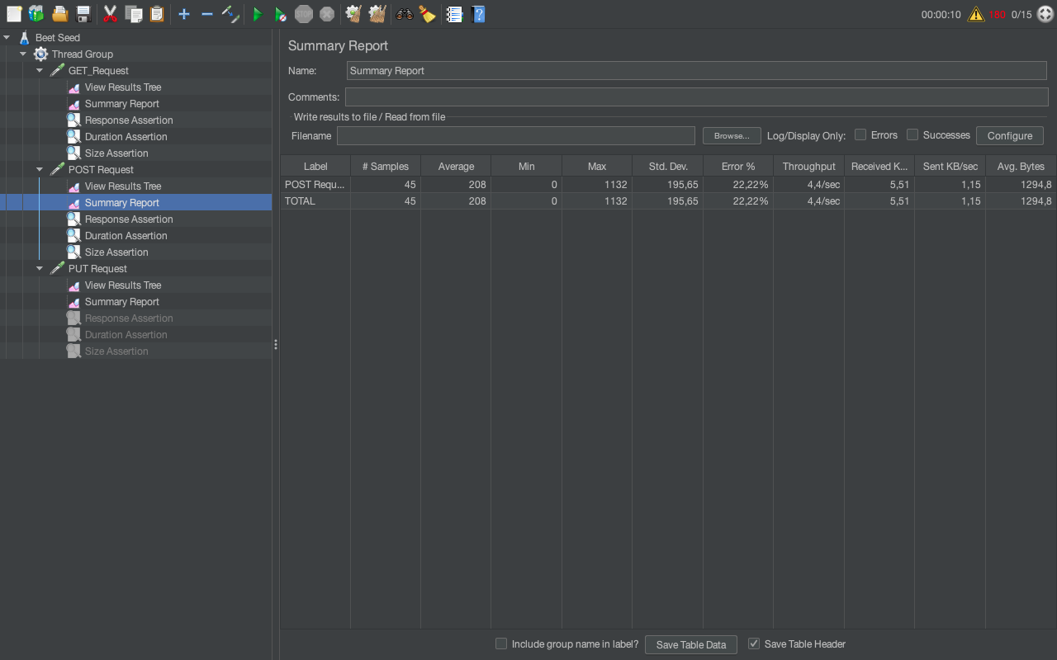

**PUT Request**

Assertion Configuration:

* Response Assertion: - Response Message - OK
* Duration Assertion: - Duration in milliseconds: 160
* Size Assertion: - Size in Bytes >=1000

View Results Tree

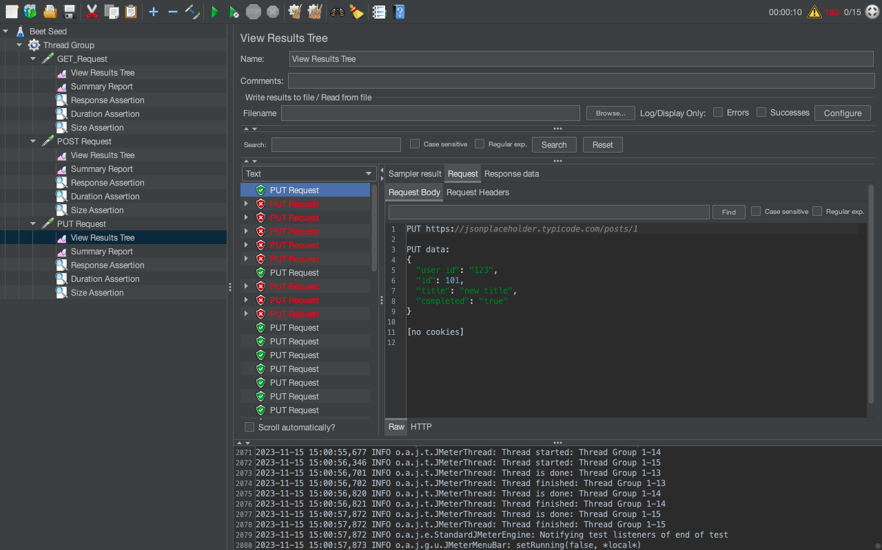

Summary Report

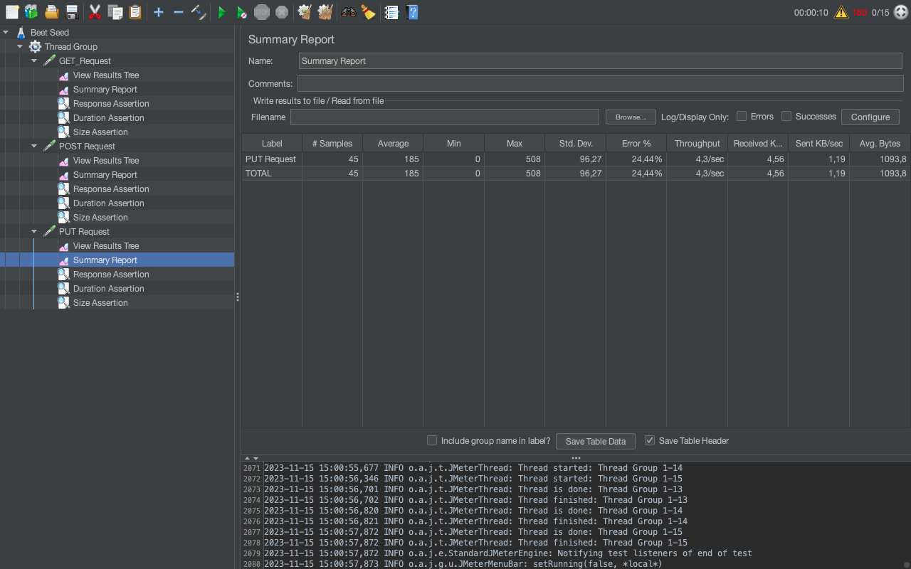

**PATCH Request**

Assertion Configuration:

* Response Assertion: - Response Message - OK
* Duration Assertion: - Duration in milliseconds: 150
* Size Assertion: - Size in Bytes >=1300

View Results Tree

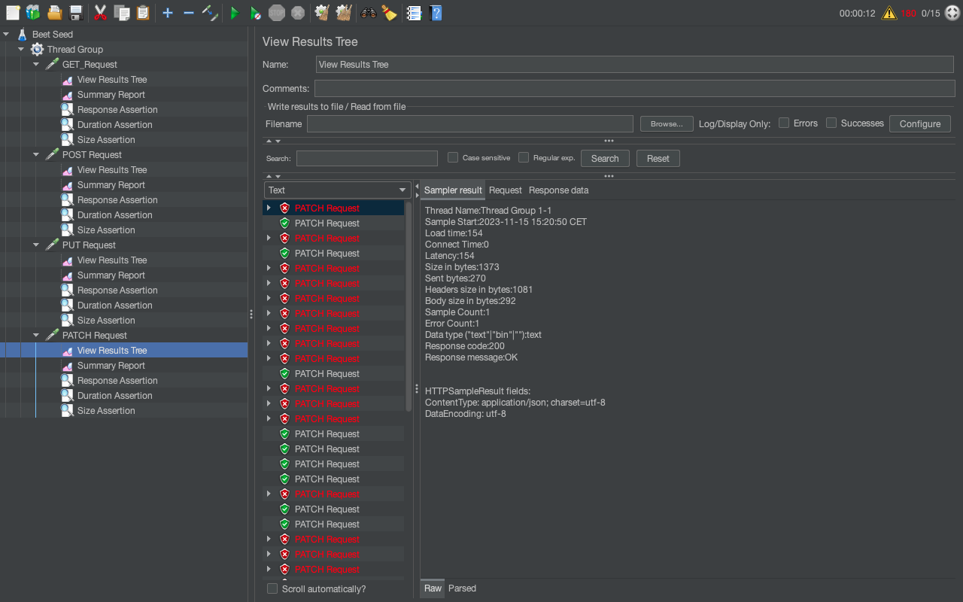

Summary Report

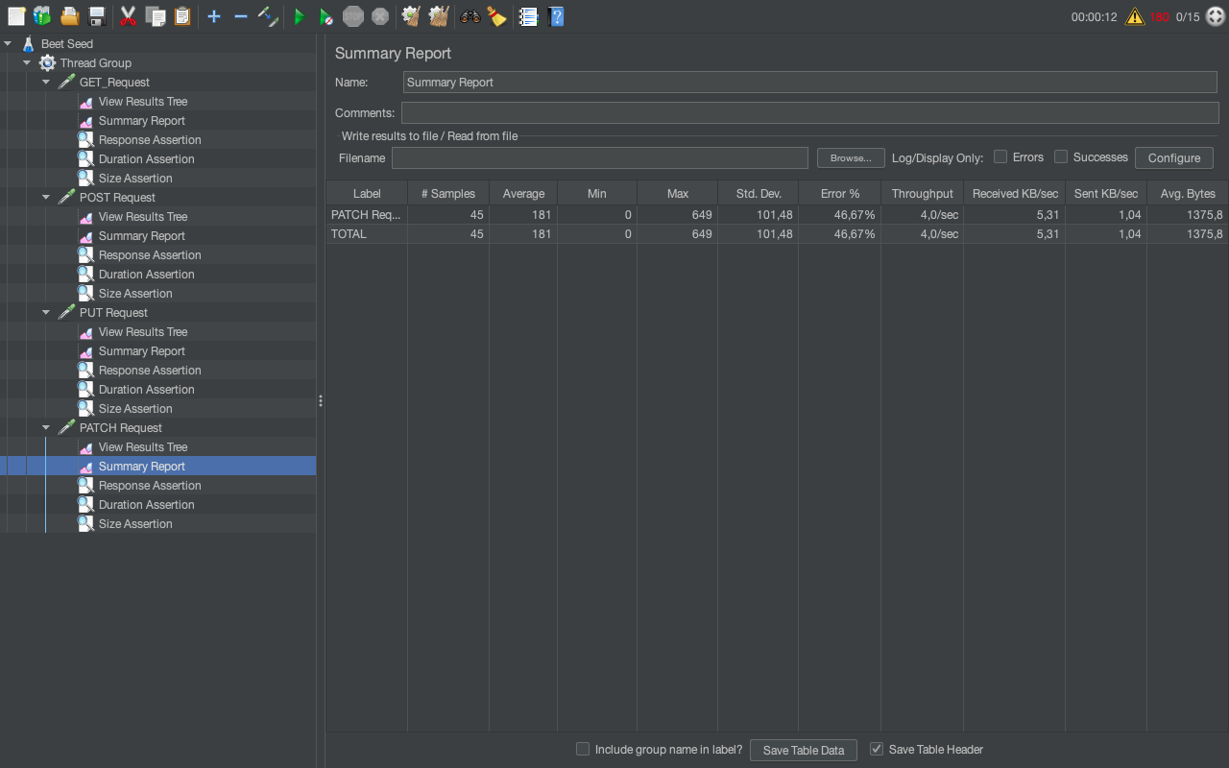

DELETE Request

Assertion Configuration:

* Response Assertion: - Response Message - OK
* Duration Assertion: - Duration in milliseconds: 160
* Size Assertion: - Size in Bytes >=1081

View Results Tree

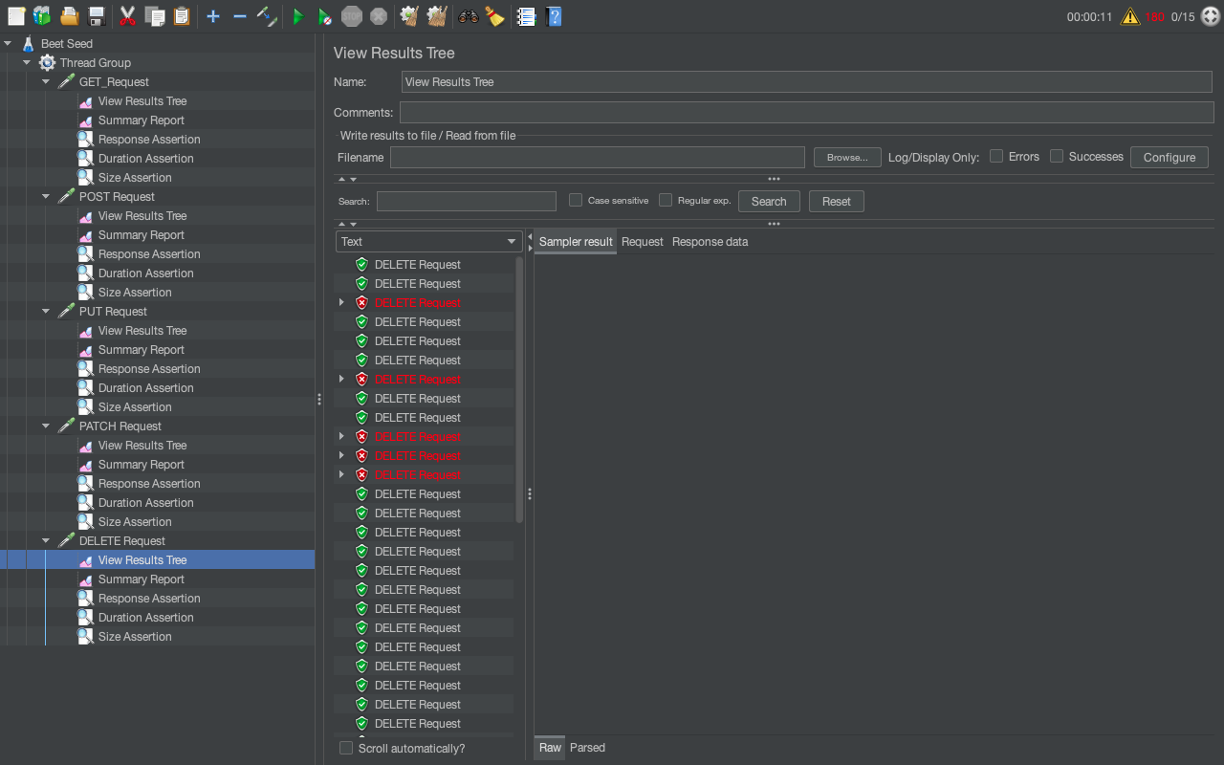

Summary Results

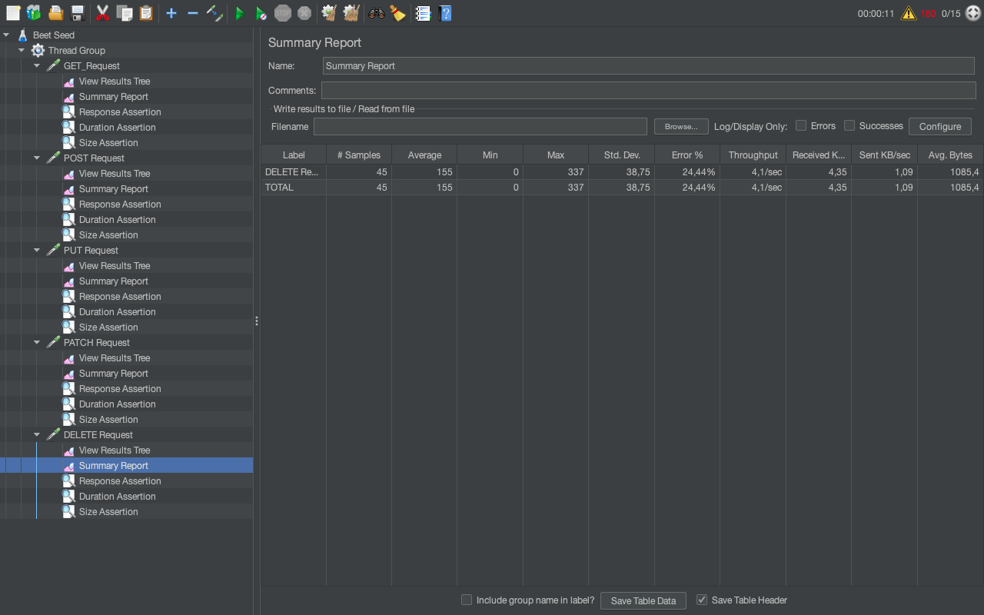

**Conclusions**

Test Results Analysis - JSONPlaceholder API

Summary of Findings:

- Overall, the API performed well with low average response times for GET requests.

- However, POST requests showed higher response times, especially in the second iteration.

Performance Metrics:

GET: Throughput - 14,6 min; Error Rate: 39,93%

POST: Throughput - 15,5 min; Error Rate: 33,99%

PUT: Throughput - 9,7 min; Error Rate: 15,56%

PATCH: Throughput - 11,0 min; Error Rate: 31,11%

DELETE: Throughput - 2,1 sec; Error Rate: 24,44%

Issues Identified:

- Assertion failures observed in PATCH requests due to mismatched response data.

- Some DELETE requests resulted in '404 Not Found' errors.

Recommendations:

- Investigate and rectify PATCH request assertion failures.

- Address '404 Not Found' errors in DELETE requests by verifying resource existence before deletion.